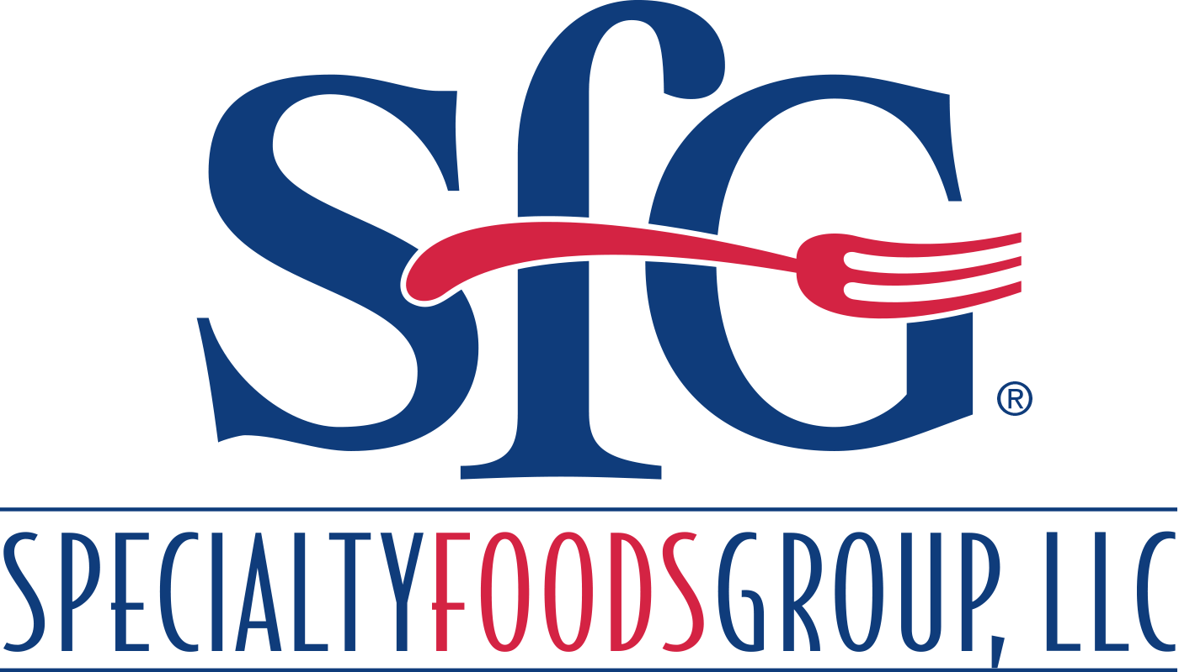
Mechanical Maintenance Technician
Specialty Foods Group, LLC – Owensboro, Kentucky
Specialty Foods Group, LLC (SFG), a dynamic pork processor and packager based in Owensboro, Kentucky, is looking for a motivated Mechanical Maintenance Technician to work in our world-class facility. The Mechanical Maintenance Technician is responsible for supporting the production operation by minimizing equipment downtime and completing preventative and corrective maintenance.
If you are interested in this unique opportunity for a growing company that helps feed the world, then look no further than Specialty Foods Group.
Responsibilities:
- Support the production operation by providing immediate response to all breakdowns to minimize equipment downtime
- Completing preventative and corrective maintenance on various meat processing equipment
- Systematically troubleshoot and resolve issues with various facility equipment and tools
- Perform minor electrical work not requiring a licensed electrician such as replacing light bulbs, fuses, breakers, etc.
- Perform other duties as needed or required
Qualifications:
- Industrial Maintenance Degree preferred, High School Diploma with 3-5 years’ experience will be considered
- 1 to 2 years working in an industrial maintenance role
- Knowledge of 110-, 220- and 480-volt electrical systems
- Experience in maintaining mechanical drives, chain drives and conveyor systems
- Willingness to work extensive overtime, including weekends as needed
- Must be able to read and comprehend various prints, schematics and other company related documents
- Experience in performing basic machine alignment using precision instruments
- Knowledge of hydraulics, pneumatics, and gear boxes
- Ability to multi-task in a fast-paced environment
- Ability to work in extreme hot, cold, wet, humid, and odorous environments
- Uphold company policies and ethical standards
- Must possess personal hand tools for the position
- Commitment to follow safety policies and practices
- Willingness to complete Confined Space training
- Hazmat certification a plus
- Must be able to successfully pass IPC's internal maintenance test

Specialty Food Groups offers its full-time team members excellent benefits including: Medical, Dental, and Vision and other insurance options. SFG also provides eligible team members with Tuition Reimbursement and Discount Days. Work includes extreme cold environments, standing for extended periods of time, repetitive motions and lifting, and working with raw meat products.
Interested candidates can apply online at www.specialtyfoodsgroup/careers.
We will accept in-person applications for one day only on Friday December 18th from 8:00 AM until 5:00 PM at the Guard Shack located 6 Dublin Lane, Owensboro, KY.
EOE, including Disability/Veteran

